**Robot Project: Mr. Grabs’ User Guide**

**Nicholas Mutlak**

**University of Toronto**

**August31st, 2023**

**Introduction**

During the summer of 2023, a robot that will be referred to as ‘Mr. Grabs’ was designed, built, and programmed in a 6-week timeline. The purpose of this robot was to accompany a separate project being developed on a computer by another student, that would involve both facial and voice recognition and interaction with human beings. The robot would allow for the computer of that project to be mounted onto it, and from there make the features of that project mobile and more expressive through the use of mechanical arms. This guide entails how to use the robot.

**Step-by-Step Setup Guide for New Users**

In order to control the robot, you will need:

1. An android phone to use as your controller, as well as another device of any kind with access to the internet.

On your computer or separate device:

1. Go to “ai2.appinventor.mit.edu/” and create an account.
2. Import the BLE5.aia file, under the BluetoothApp folder, to a new project MIT App Inventor (refer to Figure 1)

On your android phone:

1. On the android PlayStore, install the app: MIT AI2 Companion (refer to Figure 4)
2. Pair phone with computer’s MIT App Inventor online sketch (refer to Figure 2, 3 and 5)

On your robot:

1. Plug in the 4V power supply line to power the Adafruit Feather 32u4 Bluefruit LE boards (refer to Figure 6a and 6b)
2. Plug in the 5V USB power supply for the Arduino Nano 33 BLE (refer to Figure 7a and 7b)
3. Close the breaker to connect the 12V power supply line (refer to Figure 8)

Finally:

1. Connect to the Arduino Nano 33 BLE via the bluetooth app on the android phone.

Figure 1: Import Project Using Projects Dropdown

Figure 2: Connect to Phone through AI Companion in Connect Dropdown

Figure 3: Scan QR Code or Enter 6-Letter Code to Pair the Computer Sketch with the Phone App

Figure 5: MIT AI2 Companion App Pairing Menu

Figure 4: MIT AI2 Companion App

Figure 6a: Location of the 4V Battery (Positive Terminal Will Be Unconnected)

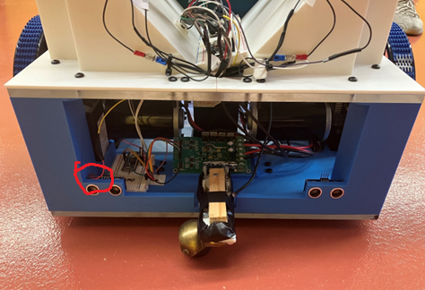

Figure 6b: Location of the 4V Battery Supply Free-Hanging Power Line

(Connect End to Positive Terminal of 4V Battery)

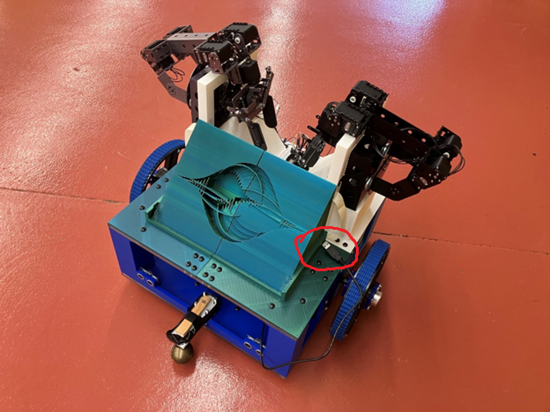

Figure 7a: Connect USB Cable to a Laptop Mounted on Top of the Robot’s Logo

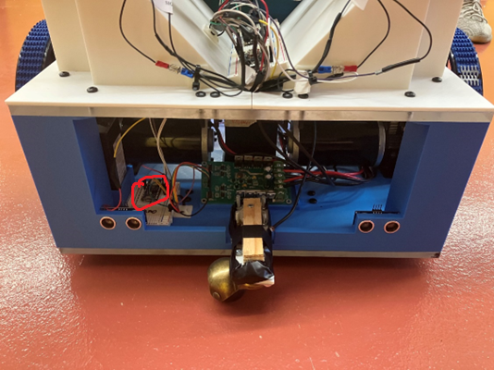

Figure 7b: Connect the Other End of the USB Cable to the Arduino Nano 33 BLE

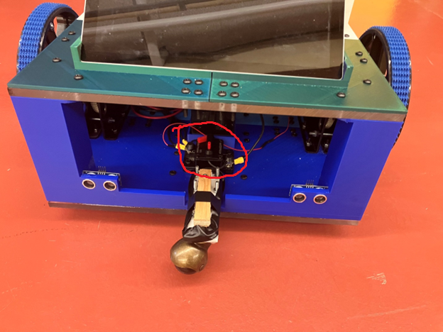

Figure 8: Location of the 30A Breaker

**Bluetooth App Controller**

Wheel Movement Options:

* Up Arrow – Updates Speed and Direction of Wheels to Forwards
* Down Arrow – Updates Speed and Direction to of Wheels to Backwards
* Left Arrow – Updates Speed and Direction to of Wheels to Left
* Right Arrow – Updates Speed and Direction to of Wheels to Right
* STOP Button – Updates Speed of Wheels to 0
* Slider – Sets, but does not update, Speed of Wheels

Mechanical Arm Options:

* Green Startup Button – Tells Arms to move to their Undocked Position
* Wave Button – Will alternate between Arms, having them perform the Wave action
* Red Shutdown Button – Tells Arms to move to their Docked Position

WARNINGS

1. DO NOT EXCEED a speed of 30 on the speed controller slider. The castor wheel mounts will not be able to withstand the force being applied to them when turning.
2. DO NOT SPAM the buttons. The Arduino Nano 33 BLE, although fast for an Arduino board, takes time to process each button press; Spamming buttons will cause instructions to pile up, especially with regard to the mechanical arms.
3. DO NOT DISCONNCT from the Arduino Nano 33 BLE board while the robot is in motion, as it will continue to be in motion. Ensure to hit the STOP button and stow away the mechanical arms before disconnecting from the Arduino Nano 33 BLE. This potential problem can be fixed with a ‘disconnect event handler’ if added to the Arduino Nano 33 BLE’s code.
4. Due to complications with the motorcontroller board only one of the wheels is able to spin backwards.
5. Due to complications with the silver mechanical arm’s first servo, it is not able to correct itself to keep the arm upright. It may fall down if the robot is in motion while the mechanical arms are not docked
6. When done using the robot, ensure to hit the breaker for the 12V battery, disconnect the positive terminal of the 4V battery, and disconnect the 5V USB power to the nano. The batteries using on the robot are rechargeable, but the lab does not have a battery charger.